# **Fintech Finnova Laboratory**

Fintech Lab is a place for students providing some services like; accommodation space, training and new infrastructures base on financial technologies and is a bridge between industry and talented students.

This center presents important services such as providing innovative strategies in financial industries and ecommerce, employment in programming and software development, changing ideas into expandable businesses in business intelligence, block chain, FinTech and analyzing services. The organizations and companies can present their own challenges and issues in this space according to their field, and then students provide their strategies. Also, the students can hold their favorite events and education workshops in this lab.

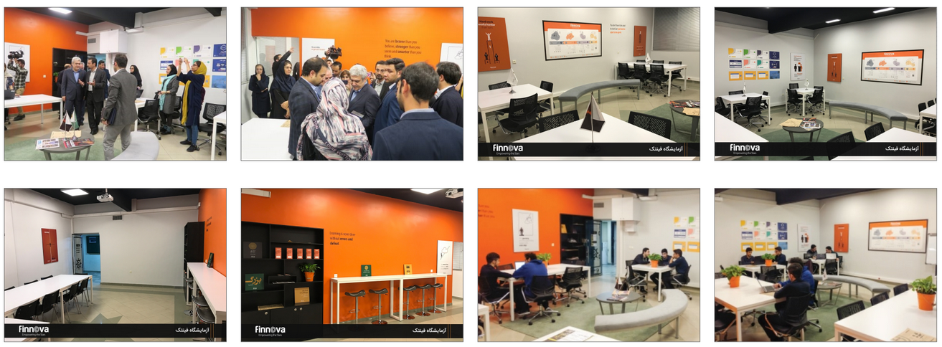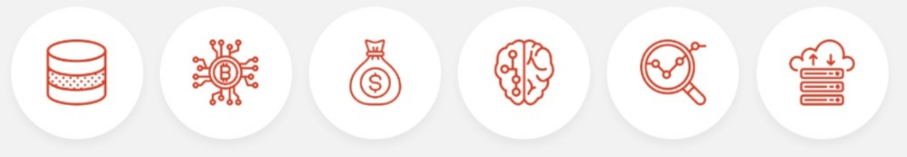

|  |  |  |  |  |
| --- | --- | --- | --- | --- |
| Team Name | Field | Leader | Number of Members | Establishment Date |
| Lakra | Clothing | Alireza Kavousi | 5 | 18 November 2019 |
| Emperor | Tourism | Amirhossein Saghafi | 5 | 27 November 2019 |
| Persa | Social Media  Search Engine | Mohammad Moein Hajebrahimi | 2 | 3 December 2019 |
| BDfood | Food Reservation  Automation Datamining | Mohammadhassan Shahrian | 2 | 24 December 2019 |
| ceit3 | Content Production | Ali Nazari | 4 | 22 February 2020 |

**Currently, the following teams are active in AUT’s Fintech Lab**

**Teams based in Fintech Laboratory can send requests to use infrastructure services of new financial technologies including services provided and introduced in Fintech Lab.**

**Every 2 weeks startups can request Finova's coaching and consulting services by sending a consultation request form and be placed in the coaching program of Finnova.**

**Teams based and active in the field of fintech will have priority in acceptance in acceleration courses, investment and using coworking space in order to develop their business.**

**Priority in Admission**

**Infrastructure Services**

**Mentoring & Consulting**

**FinTech**

**Business Intelligence**

**Analyzing Services**

**Cloud Services**

**Blockchain**

**Artificial Intelligence**

**Admission Fields**

**Current Active Teams**

**Finnova Services**